Fossils (Grades 2-5)

Tennessee State Standards Covered
GLE 0207.Inq.1 Observe the world of familiar objects using the senses and tools
GLE 0207.Inq.2 Ask questions, make logical predictions, plan investigations, and represent data
GLE 0207.Inq.3 Explain the data from an investigation
0.207.Inq.3 Communicate understanding of simple data using age-appropriate vocabulary
0.207.Inq.4 Collect, discuss, and communicate findings from a variety of investigations
GLE 0207.1.1 Recognize that plants and animals are made up of smaller parts and use food, water, and air to survive
GLE 0307.Inq.1 Explore different scientific phenomena by asking questions, making logical predictions, planning investigations, and recording data
GLE 0307.Inq.2 Select and use appropriate tools and simple equipment to conduct an investigation
GLE 0307.Inq.3 Organize data into appropriate tables, graphs, drawings, or diagrams
GLE 0307.Inq.4 Identify and interpret simple patterns of evidence to communicate the findings of multiple investigations
GLE 0307.Inq.5 Recognize that people may interpret the same results in different ways
0307.Inq.1 Identify specific investigations that could be used to answer a particular question and identify reasons for this choice
0307.Inq.2 Identify tools needed to investigate specific questions
0307.Inq.3 Maintain a science notebook that includes observations, data, diagrams, and explanations
0307.Inq.4 Analyze and communicate findings from multiple investigations of similar phenomena to reach a conclusion
0507.Inq.4 Analyze and communicate findings from multiple investigations of similar phenomena to reach a conclusion
0507.5.1 Classify animals according to their physical characteristics
*Embedded Inquiry for Grades 3-5 is identical.

ACTIVITY 3:
Materials:
For each student:
- Hand lenses
- Box & T-Chart
- Student Science Notebooks
- Matching Fossils Pictures
- Matching Fossils Descriptions
- Copy of KWL from Activity 1

For class:
- Transparency of Box & T-Chart
- Transparency of KWL from Activity 1
- Matching Fossils Descriptions

Preparations:
- Cut sheets of blank copy paper

Procedures:
1. Review the last session on fossils and concepts such as:
• It takes special conditions to make a fossil.
• Fossils give us clues to life and the environment of long ago.
• Fossils help us understand plant and animal species over time.

2. Pass out the Box & T-Chart to use when comparing the Brachiopod fossil and the Trilobite fossil.

3. Once again, show the Brachiopod and Trilobite fossils to each student. Ask students to discuss how the Brachiopod and Trilobite fossils are the same.

4. Ask students to share their responses.

5. Capture some responses on the white board or overhead projector.

6. Next, ask students to enter responses about how the two fossils are the same
in the top box of the Box & T-Chart on their own paper. Information can come
from their own knowledge, their partner or from the group discussion (see sample).

7. Move to the lower portion of the Box & T-Chart. Ask students to turn to their partner to discuss how these two fossils are different. Capture some of the responses on the board.

8. Ask students to enter responses in the T part of the chart both from the initial group discussion about the differences and their discussions with their partner (see sample).

9. Have students attach the Box & T-Chart to their science notebooks.
- EXTENSION: Have students do a second Box & T-Chart with two fossils (theirs and their partner’s) to extend their understanding of similarities and differences.

10. Hand out the Matching Fossils Exercise – PICTURE PAGE:
- Students cut the pictures apart and mix them up on their desktop.

11. Hand out the Matching Fossils Exercise – DESCRIPTIONS WITH BLANKS:
- Students match the picture that best shows what the words are saying and tape it down to the page.

12. Hold a final discussion about what has been learned.

13. Pass out the KWL sheet from Day One and ask students to complete the data sheet by writing what they have learned about fossils. When finished, students place the completed KWL into their notebooks.

14. Note to Teacher: The products from these lessons (e.g., Box & T-Chart, Observations Organizer, Comparisons Writing Frame or Matching of Fossils Exercise) can be used as formative assessments from which a teacher can “mine” information about student understanding. Teachers need to realize that formative assessment is not intended to be a graded event but a way to inform instruction.

Standards for Grades 2-3: |  | EALR 4: Life Science  Big Idea: Biological Evolution (LS3)  Core Content: Variation of Inherited Characteristics
In prior grades students learned that some objects are alive and others are not, and that many living things can be classified as either plants or animals. In grades 2-3 students learn about variations in inherited characteristics. That is, when plants and animals reproduce, the offspring closely resembles their parents. But the offspring are not exactly the same as their parents. Variations among plants and animals can help them survive changing conditions. Those plants and animals unable to survive and reproduce become extinct. Fossils represent the remains of plants and animals, including some that are extinct. Many extinct plants and animals look something like plants and animals that are alive today. This topic engages students in looking closely at plants and animals and noticing similarities and subtle differences. It also lays the foundation for later study of Evolution and Earth History.
 | Content Standards  Students know that: |  | Performance Expectations  Students are expected to:
2-3 LS3D | Fossils are often similar to parts of plants or animals that live today. |  | Observe fossils and compare them to similar plants or animals that live today (e.g., compare a fossil fern with a similar fern that grows today, a dinosaur leg bone with the leg bone of a reptile that lives today, a mastodon and an elephant).
2-3 LS3E | Some fossils are very different from plants and animals that live today. |  | - Conclude from fossil evidence that once there were species on Earth that are no longer alive (e.g., T-Rex, trilobites).  - Given pictures of animals that are extinct (e.g., dinosaurs, mammoths),describe how these animals are different from animals that live today.
Standards for Grades 4-5: |  | EALR 4: Earth and Space Science  Big Idea: Earth History (ES3)  Core Content: Focus on Fossils
In prior grades students learned that fossils represent the remains of plants and animals that lived long ago. In grades 4–5 students learn that fossils also provide evidence of environmental conditions that existed when the fossils formed. Most fossils are imprints formed when plants or animals died in a watery environment and were covered with mud that eventually hardened into rock. Fossils can also form in other ways, as when dissolved minerals seep into a piece of wood and harden into rock, or an animal that is frozen in ice that never thaws. Fossils provide evidence of the kinds of plants and animals that lived on Earth in the past, as well as environmental conditions that prevailed at the time the fossils were formed.
 | Content Standards  Students know that: |  | Performance Expectations  Students are expected to:
4–5 ES3A | Different kinds of events caused the formation of different kinds of fossils. |  | • Describe an event that could cause the formation of a given fossil (e.g., the plant or animal may have been buried in sediment that hardened into rock and left an imprint, or dissolved minerals may have seeped into a piece of wood and hardened into rock).
4–5 ES3B | By studying the kinds of plant and animal fossils in a layer of rock, it is possible to infer what the environment was like at  the time and where the layer formed. |  | • Infer from a picture of several fossils in a layer of rock the environmental conditions that existed when the fossils were formed (e.g., fish fossils would indicate that a body of water existed at the time the fossils formed).

Science Standards

Standards for Grades 4-5: |  | EALR 4: Life Science  Big Idea: Biological Evolution (LS3)  Core Content: Heredity and Adaptation
In prior grades students learned about variations in inherited characteristics. In grades 4–5 students learn that some differences in inherited characteristics may help plants and animals survive and reproduce. Sexual reproduction results in offspring that are never identical to either of their parents and therefore contributes to a species’ ability to adapt to changing conditions. Heredity is a key feature of living plants and animals that enables changes in characteristics to be passed on and for species to change over time. Fossils provide evidence of what ancient extinct plants and animals looked like.
 | Content Standards  Students know that: |  | Performance Expectations  Students are expected to:
4–5 LS3D | Fossils provide evidence that many plant and animal species are extinct and that species have changed over time. |  | • Compare and contrast fossils with one another and with living plants and animals to illustrate that fossils provide evidence that plant and animal species have changed over time.

Sample Response on the Box & T-Chart

BOX & T-CHART
Similarities

Both are fossils, lived long ago, are no longer living organisms, and lived in water.

BRACHIOPOD TRILOBITE
Differences
not extinct extinct
has ridges has segments
does not have exoskeleton has exoskeleton

Differences

How are the Brachiopod and Trilobite Fossils the Same and How are They Different?
Similarities

Brachiopod Fossil | Trilobite Fossil
Adapted from Writing in Science, Betsy Rupp Fulwiler, Portsmouth, NH: Heinemann
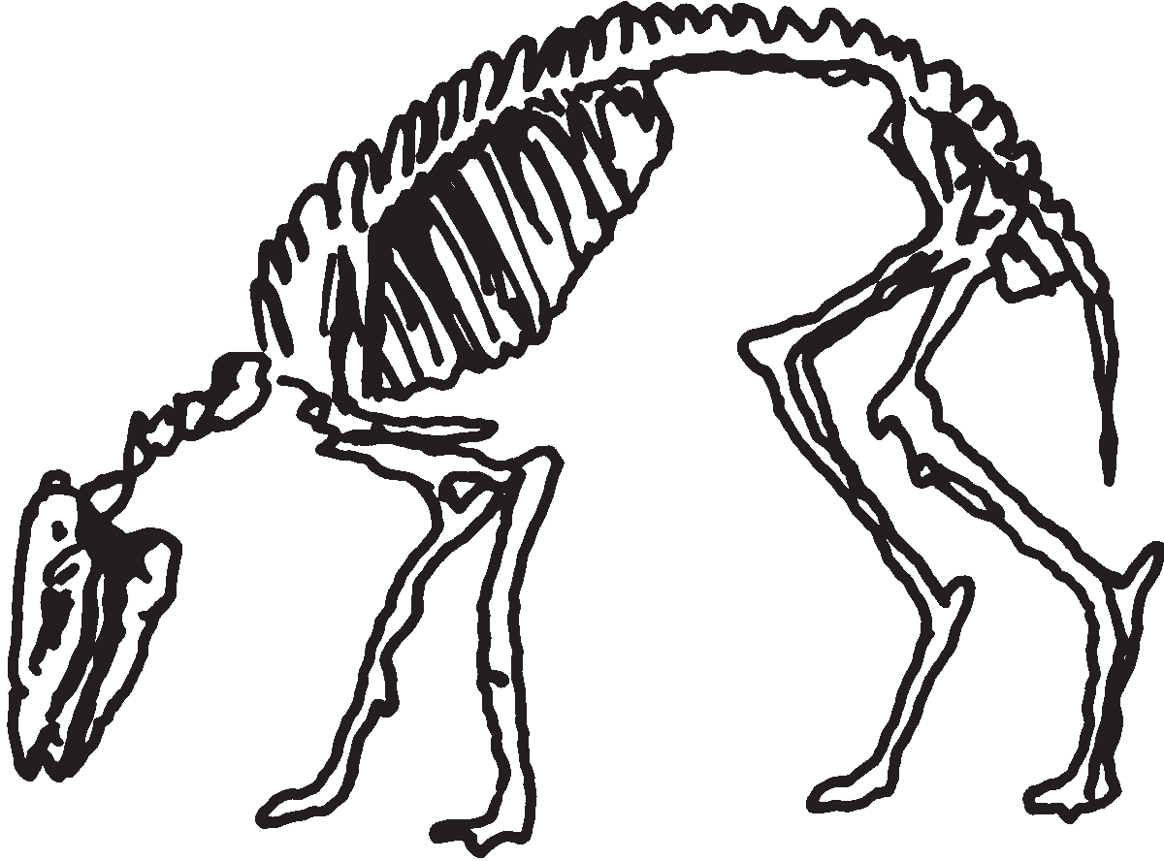
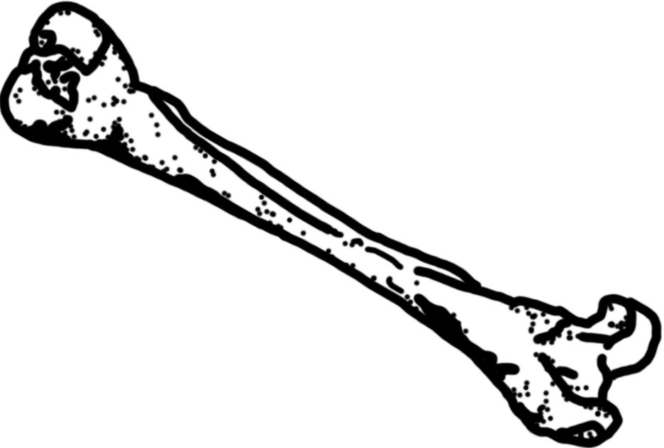
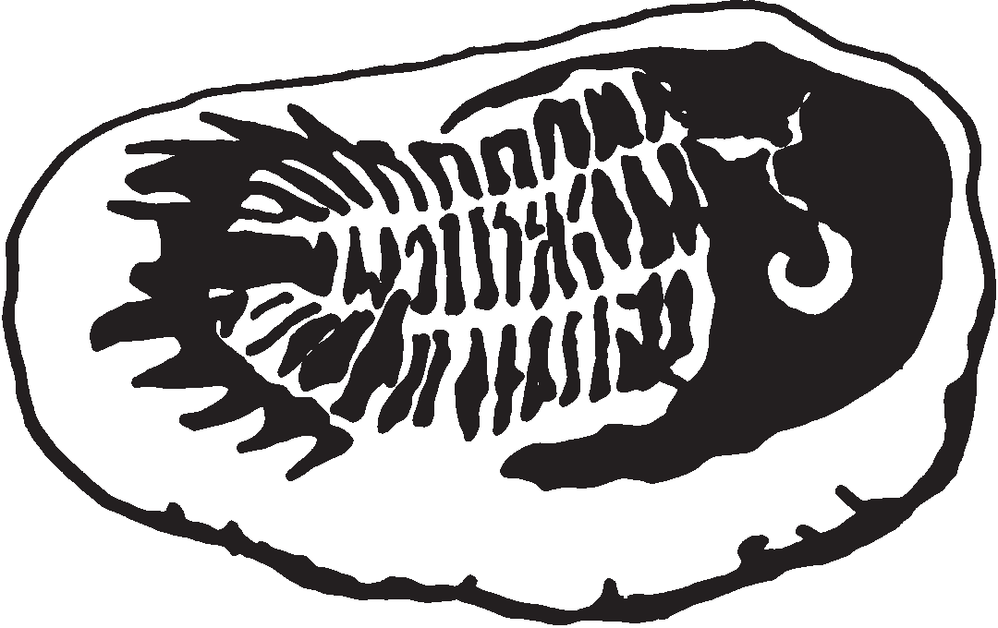
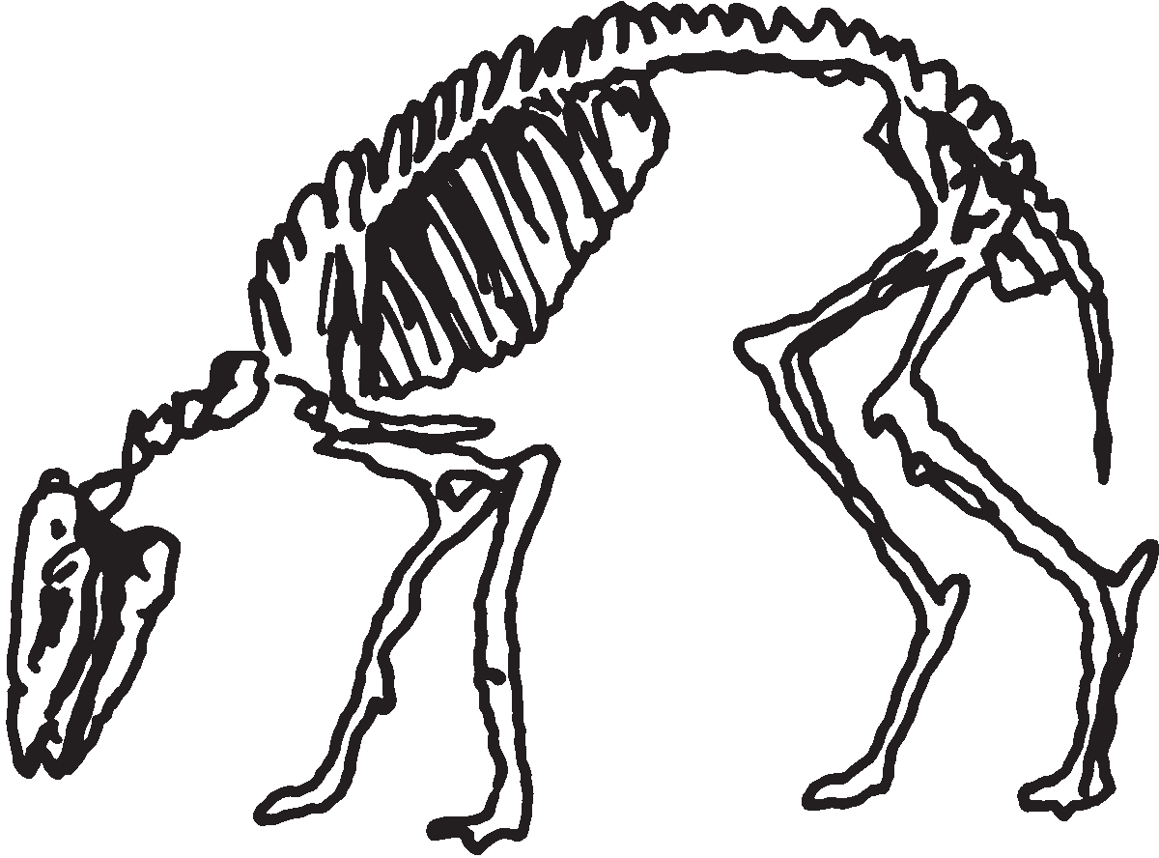
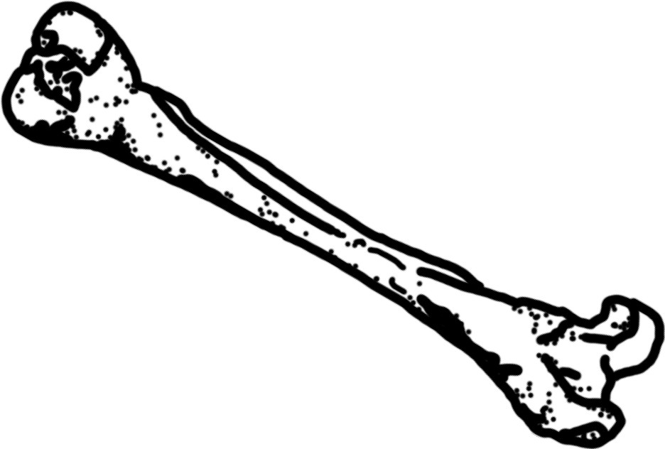
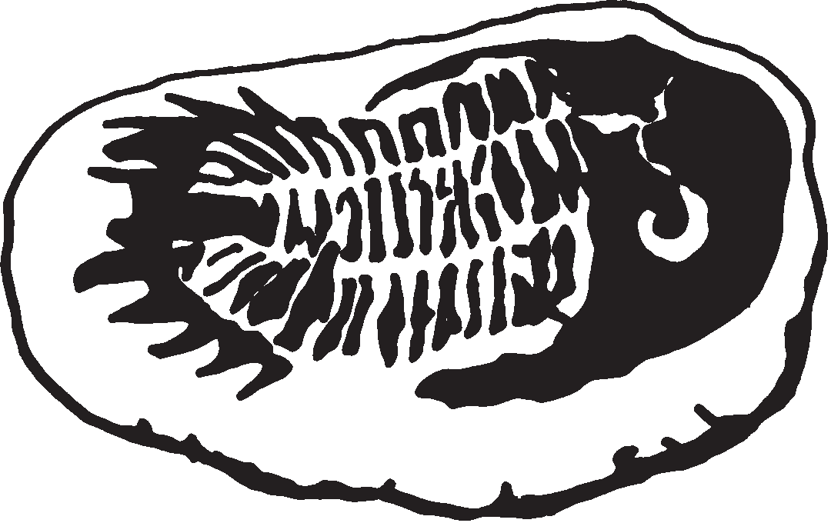

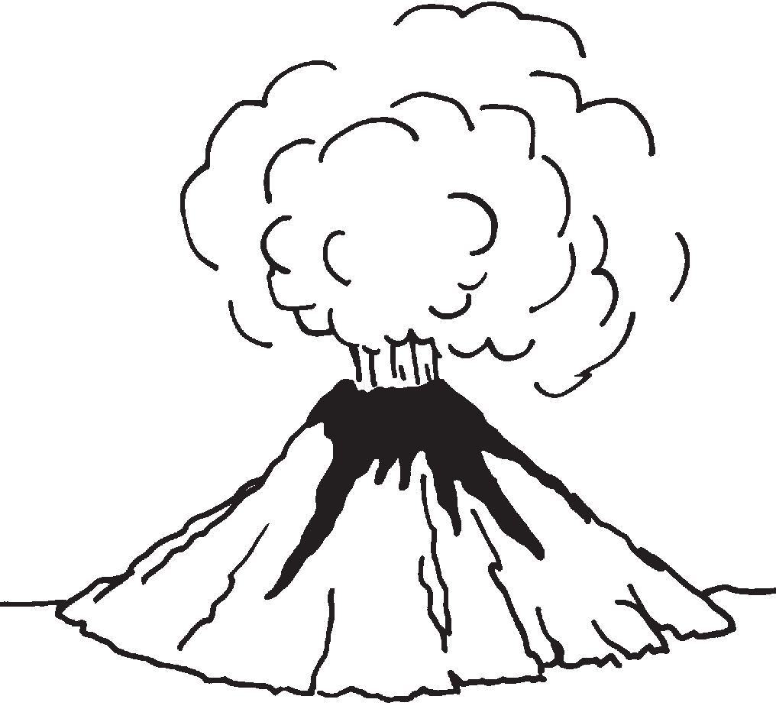
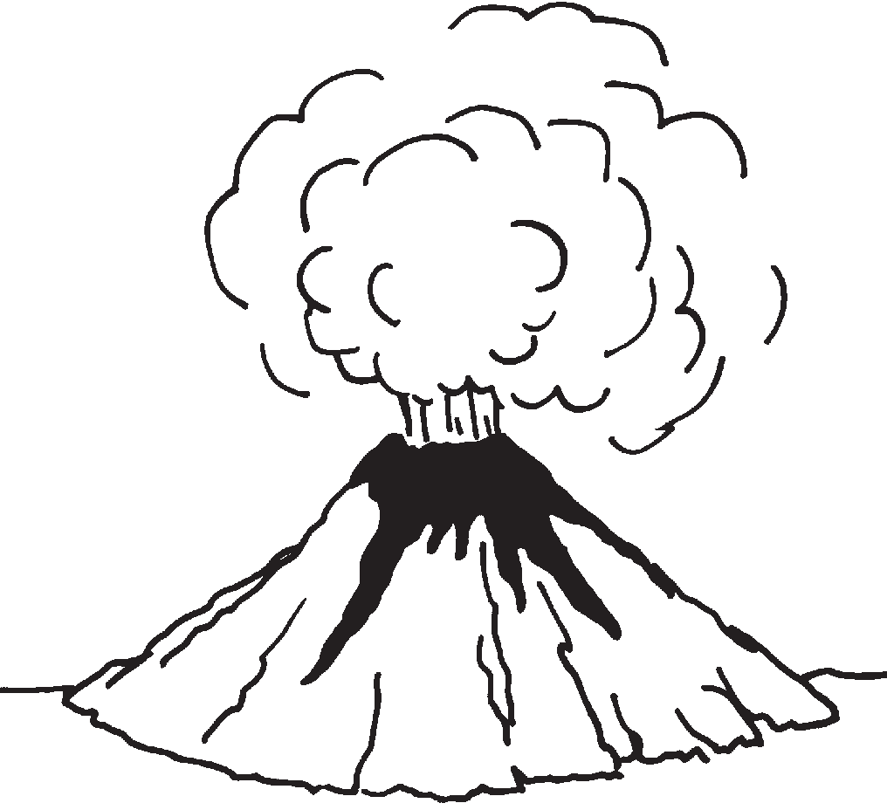
Matching Fossils Pictures

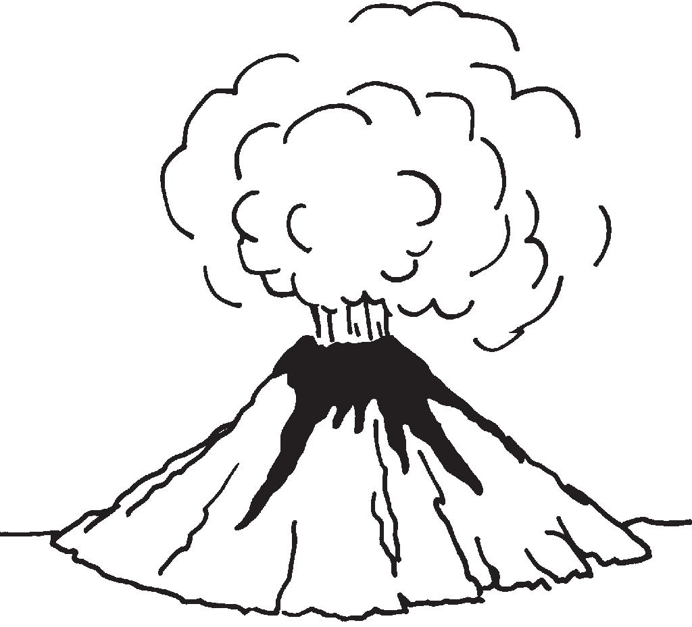

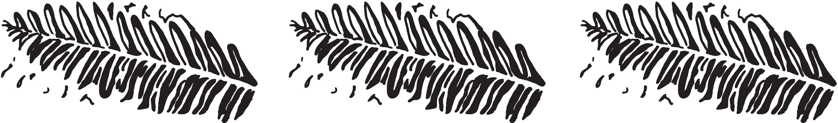

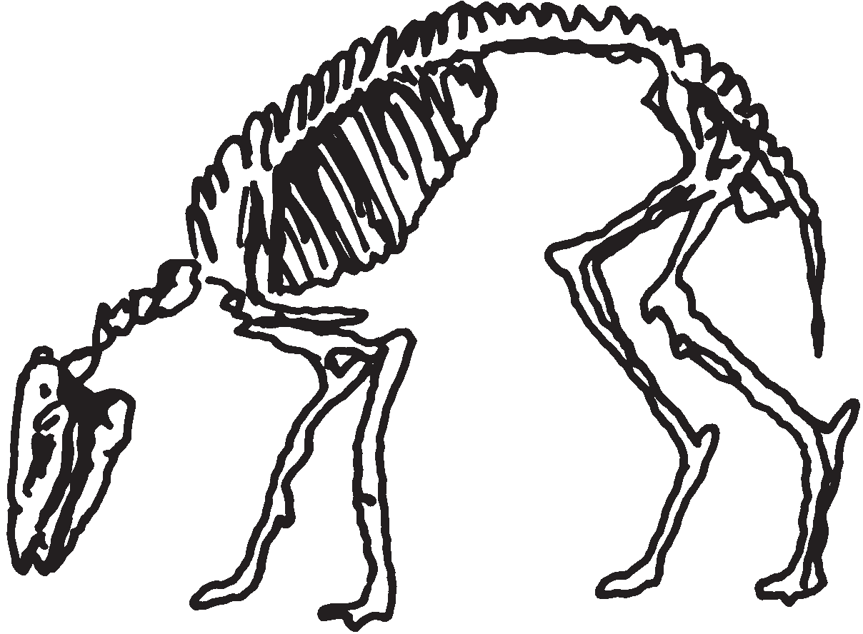

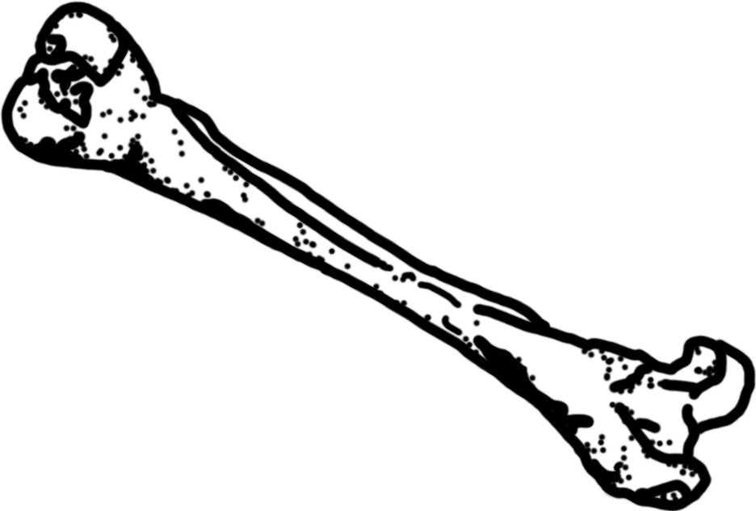

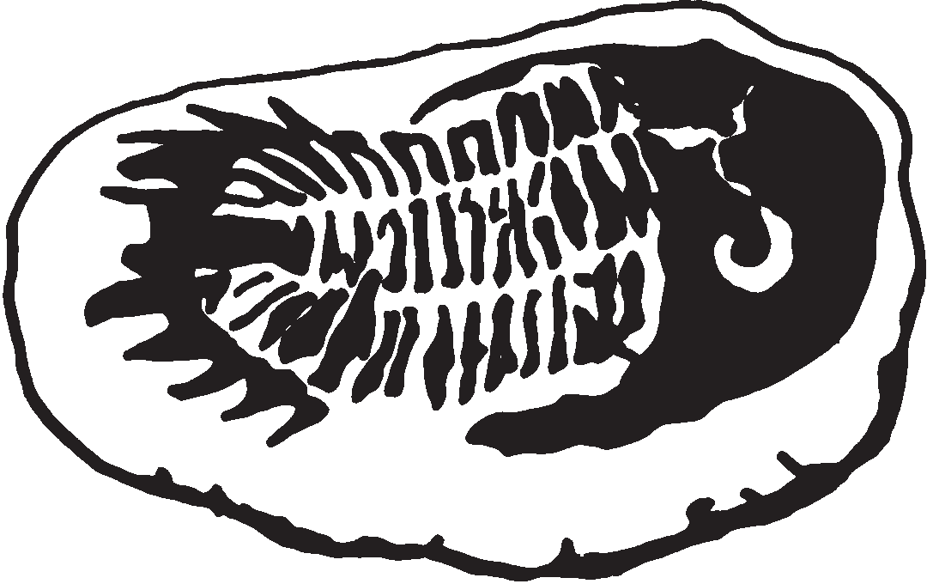

Matching Fossils Descriptions

Lava flows, mud slides, and layers of sediment
can all play a part in covering an organism as it slowly forms into a fossil.

EALR 4: 4–5 ES3A
Fossils of leaves, such as ferns, may look similar to plants that exist today.

EALR 4: 2–3 LS3D
Fossils that resemble animals that still live today, show us ways they changed (evolved)
as they adapted to their changing environment.

EALR 4: 2–3 LS3D; EALR 4: 4–5 LS3D
A paleontologist is a scientist that carefully observes and describes fossils such as dinosaur bones found in the earth.
Fossil animals, such as the extinct trilobite, give clues to animals and environments that must have existed long ago.

EALR 4: 2–3 LS3E; EALR 4: 4–5 ES3B

Lava flows, mud slides, and layers of sediment  can all play a part in covering an organism as it slowly forms into a fossil.  EALR 4: 4–5 ES3A | 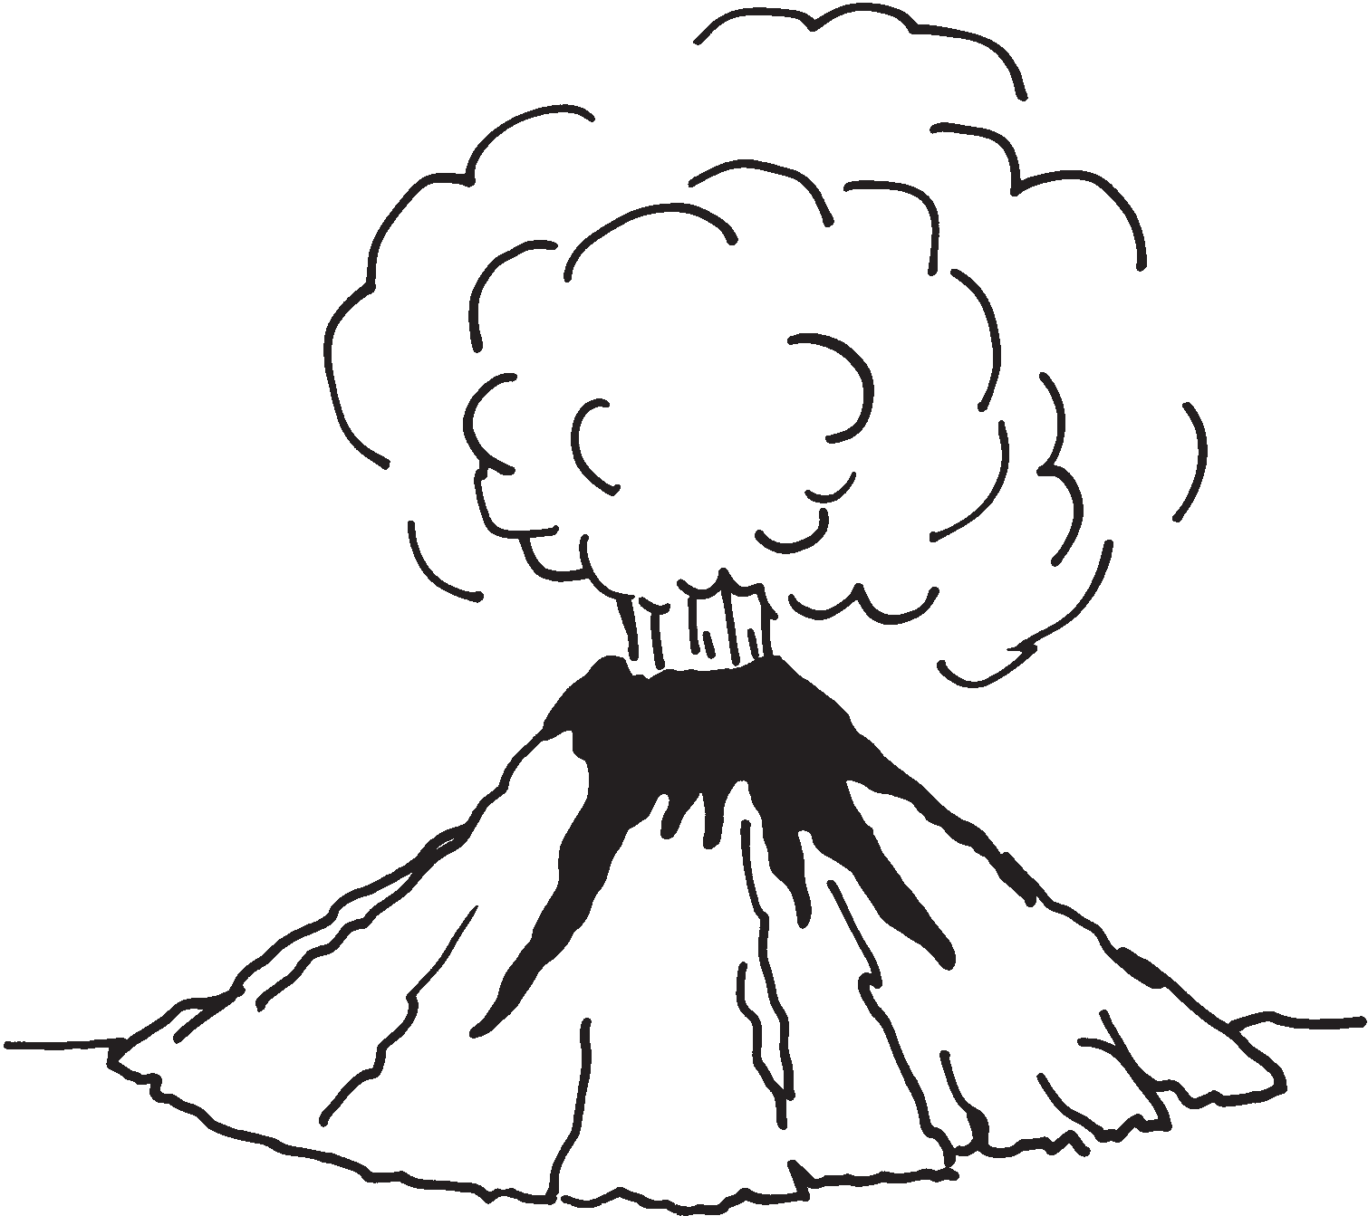
Fossils of leaves, such as ferns, may look similar to plants that exist today.  EALR 4: 2–3 LS3D | 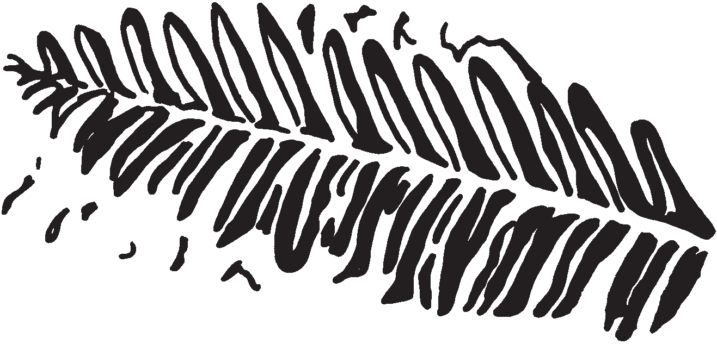
Fossils that resemble animals that still live today, show us ways they changed (evolved)  as they adapted to their changing environment.  EALR 4: 2–3 LS3D; EALR 4: 4–5 LS3D | 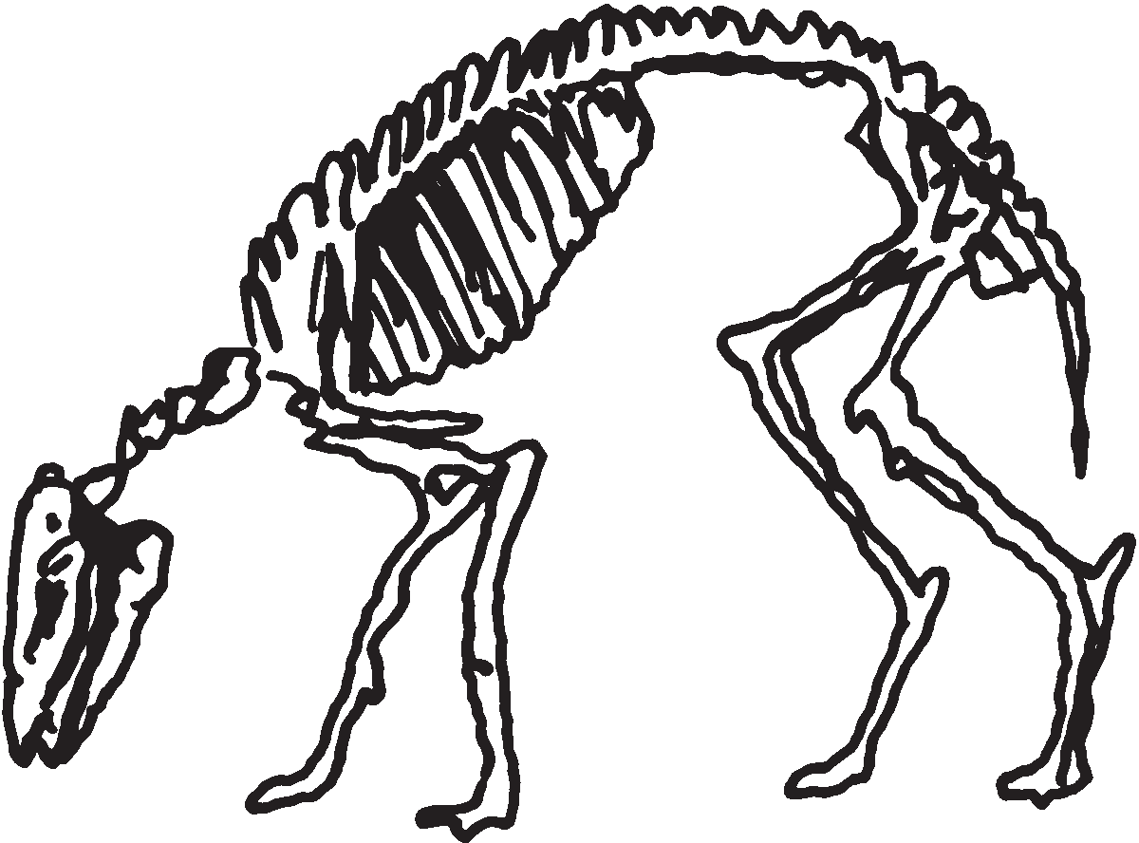
A paleontologist is a scientist that carefully observes and describes fossils such as dinosaur bones found in the earth. | 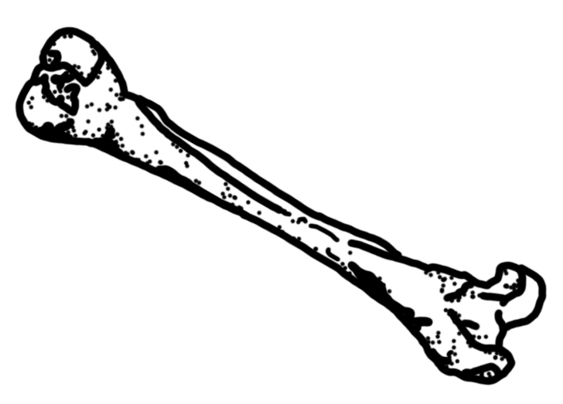
Fossil sea animals, such as the extinct trilobite, give clues to an ocean environment that must have existed long ago.  EALR 4: 2–3 LS3E; EALR 4: 4–5 ES3B | 